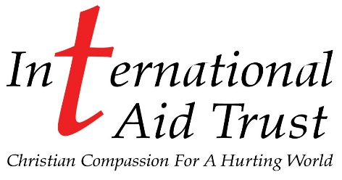

Logistics & Distribution Manager
About us:
International Aid Trust is a life changing Christian charity.
The charity’s objects are twofold: -
- The relief of persons who are in conditions of real need, hardship or distress and those who are disabled through age or sickness and in particular by the supply of financial, material and medical aid and by provision of personnel to provide hands on practical and pastoral assistance.
- The advancement of the Christian faith.
Our Motto, “Christian Compassion for a Hurting World”, covers every aspect of IAT ministry.
From small beginnings International Aid Trust has developed its sphere of influence to include not only the UK but in over 40 countries in Africa, Asia, Eastern Europe and South America.
Job Summary:
Job Type: Full-time. Hours worked between Monday - Saturday
Salary: iro £25,000.00 per year
We are looking for an effective Manager to direct receiving, warehousing and distribution operations. You will oversee the efficient receipt, storage, value-adding servicing and dispatch of a wide variety of products.
Ultimately, ensuring the warehouse operates at peak efficiency, in compliance with the organisations policies and vision.
Responsibilities include:
- Oversee daily operations, while controlling and managing inventory and logistics
- Review and prepare workflow, manning and space requirements, equipment layout and action plans while ensuring productivity, quality and service standards are met
- Maintain a safe and healthy work environment by establishing, following, and enforcing standards and procedures are complying with legal legislations
- Inspect and ensure safe use of warehouse vehicles, machinery, and equipment overseeing general maintenance as needed.
- Initiate, coordinate and enforce optimal operational policies and procedures
- Adhere to all warehousing, handling and shipping legislation requirements
- Liaising with inhouse staff, suppliers, transport companies, delivery drivers including volunteers
- Loading/offloading vehicles by hand and/or forklift
Required Knowledge, Skills and Abilities:
- Proven work experience as a Warehouse Manager
- Expertise in warehouse management procedures and best practices
- Proven ability to implement process improvement initiatives
- Leadership skills and ability manage staff including volunteers
- Strong decision making and problem solving skills
- Excellent communication skills.
- Planning and organisation skills.
- Analytical skills
- Attention to detail
- Good teamwork and time management skills
- Full clean driving licence
- Forklift truck training accreditation
Required Attitude and Personality:
- Must be reliable and have a willingness to be flexible with hours
- Good time keeping ensuring that time sensitive tasks are completed on time
- Courteous to others, both colleagues, volunteers, supporters and represent International Aid Trust positively to all visitors
- Ability to work with all levels of company staff
Note: This job description is intended to provide a general overview of the position and does not include any specific contact information.

