Dear Friends and Supporters,
As the devastating war in Ukraine draws on, with more atrocities every day, we want to say a heartfelt ‘Thank You’.
In just over a month we have sorted, packed and dispatched, seventeen 45ft articulated lorries containing more than 200 tonnes of aid. More are planned as we receive more aid and funding.
Your support for our Ukraine Emergency Appeal has been overwhelming, and a tremendous encouragement to our teams, both in the UK and in Ukraine. In the past three weeks you have donated huge amounts of food, medical supplies, toiletries, clothing, and bedding. Our warehouse has welcomed over 100 volunteers, who have worked very hard sorting and packing this aid. You have also given generously of your finances and stood with us in prayer.
A special thanks to BGA Logistics for their huge help, and to all the Churches, Rotary Clubs and other groups who have hosted drop off points for aid.
Some of the lorries sent have gone to Poland, Romania, Moldova, and Hungary, where we have long established partnerships with churches and Christian organisations who are now caring for Ukrainian refugees.
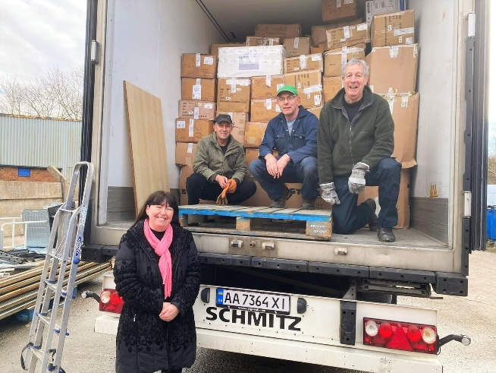 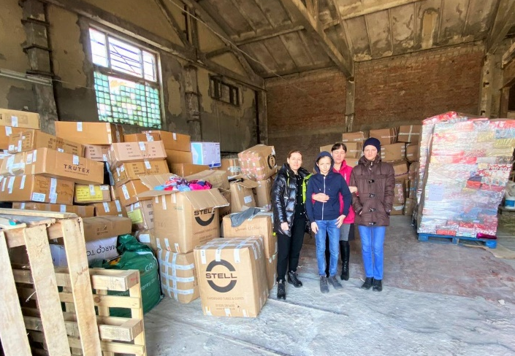(left: Aid loaded for Moldova, right: the same aid unloaded in Pastor Victor’s warehouse, ready for distribution)
Some of the loads have been sent into Ukraine or to warehouses near the border, where our teams, led by our Ukraine Director Pastor Pasha, can collect provisions from. Thanks to your generosity we have also been able to send substantial funds for the team to buy food from wholesalers on the borders, and also to pay for another new van to help transporting all these supplies.

All the International Aid Trust staff and volunteers in Ukraine have stayed in place to continue supporting the elderly, disabled, impoverished and others not able to evacuate.
We praise God for the teams’ love for Him and their love for those they serve. They are daily on the streets of beleaguered cities and other hard-hit areas; delivering food and other essentials, and giving pastoral support, despite the dangers to themselves. Pasha has driven over 600 miles in a day, delivering relief.
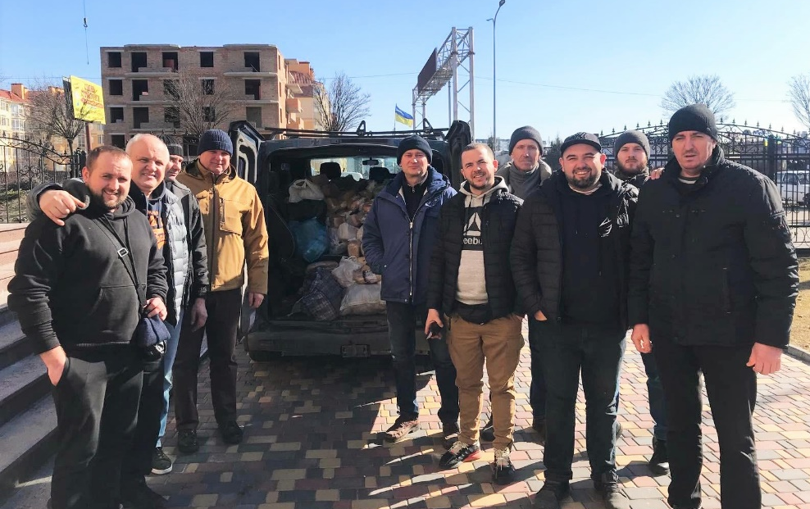
(Pastor Pasha, 2nd left and the team from Soborna Church, delivering food and essentials in Kyiv)

Please continue to pray with us for an end to this dreadful war, please pray for protection and strength for all our team in Ukraine and for all Christians to shine as a light in their communities in these dark times.
Thank you again for standing with the people of Ukraine, our support will be needed for the foreseeable future. We still need donations of food, medical supplies, toiletries, sleeping bags and shoes (no other bedding or clothes at this time please). We still need volunteers at the warehouse for packing, sorting, brewing tea - and any other skills you have - to help process all the wonderful donations. We continue to need financial support for the transportation of this aid. And most of all, please keep praying!
Ukraine has stood up for its right to exist in peace, and Ukraine is now turning back the invaders. Only God could have made this happen.
With love and blessings to all of you

Bernard
Rev Bernard Cocker
CEO & Founder

